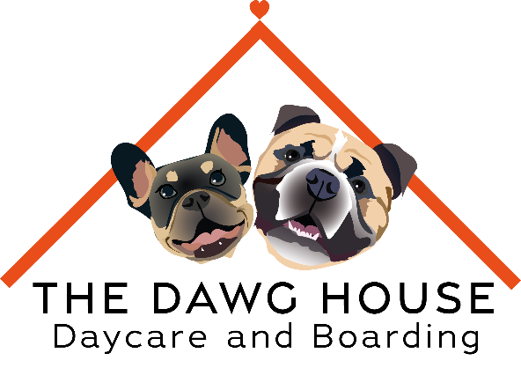

The dawg house trial form
Dogs name ______________________________________________________________________________
Age __________________ DOB _____________________________________________________________
Breed __________________________________________________________________________________
Owners Name ___________________________________________________________________________
Contact Number _________________________________________________________________________
Emergency Contact _______________________________________________________________________
Vets __________________________________________________________________________________
Vets Contact Number _____________________________________________________________________
A few questions about your dog
IS YOUR DOG MALE / FEMALE
IS YOUR DOG OVER 1 YEAR OLD YES / NO
IF MALE HAS YOUR DOG BEEN NEUTERED YES / NO
(DUE TO LICENSING REGULATIONS, WE ARE NOT ABLE TO TAKE MALE DOGS OVER 1 YEAR OLD THAT HAVE NOT BEEN NEUTERED)
I AGREE THAT IF MY FEMALE DOG HAS NOT BEEN SPAYED THAT SHE IS NOT IN SEASON CURRENTLY YES / NO
(FEMALE DOGS CANNOT ATTEND WHILE IN SEASON)
I AGREE THAT MY DOG IS UP TO DATE WITH ALL THEIR VACCINATIONS INCLUDING KENNEL COUGH
YES / NO
(Kennel Cough vaccine is a separate vaccine to their annual ones and has to be requested at the vets. We CANNOT take any dogs that have not had this)
I AGREE TO PHOTOS BEING TAKEN OF MY DOG AND USED ON SOCIAL MEDIA PLATFORMS YES / NO
HAS YOUR DOG EVER SHOWN ANY SIGNS OF AGGRESSION YES / NO
DOES YOUR DOG ATTEND ANOTHER DAY CARE SETTING YES / NO
Unfortunately to help stop the spreading of illnesses and diseases and also to help your dog get in a good routine with us we are unable to take dogs that attend any other day-care. This does not include dog walking services.
IN ORDER TO KEEP YOUR DOGS PLACE AT DAYCARE THEY MUST ATTEND AT LEAST 1 X PER MONTH, DO YOU HAVE PREFFERED DAYS TO ATTEND DAYCARE ?
MONDAY | TUESDAY | WEDNESDAY | THURSDAY | FRIDAY | Saturdays

Important Information
- At the dawg house we familiarise dogs with other dogs in an open setting, this includes dogs of different age groups and breeds.
- Unfortunately, we cannot be held liable for any vets’ fees from incidents that have occurred at day care.
- Any aggressive or disruptive behaviour towards other dogs or staff is not accepted here and you may be asked to leave if this happens
- Trial Sessions last for 5hrs and cost £16
- Day-care is open from 7am – 6pm, late pickups may incur a charge of £5 per 15mins
- Puppy days (Saturdays) are 9am – 3pm
I understand and accept all mentioned in this form
Signed ___________________________ Date ______________________________

Any futher comments ?
_______________________________________________________________________________________________________________________________________________________________________________________________________________________________________________________________________________________________________________________________________________________________________________________

For staff use only
How has the dog been on there trial?_______________________________________________________________________________________________________________________________________________________________________________________________________________________________________________________________________________________________________________________________________________________________________________________

Is the dog allowed to attend daycare again? _______________________________________
Did the dog display any aggressive/ Disruptive behaviour? ___________________________
Staff signature ______________________________________________________________

